# Prescription Labels

Prescription Label Features

Examples of Applied Labels

Applying the Label Manually

Flagging Labels

**Description:** CVS Caremark Mail Order Pharmacy utilizes several sizes of prescription labels depending how the medication is dispensed. All labels include a 2-D barcodes instead of the traditional barcodes.

|  |
| --- |
| Prescription Label Features |

Important Icon**Existing and future barcodes are for internal use only.** If scanned/decoded with a code reader smart phone app, these barcodes provide a unique internal reference number. The barcode does not include the prescription number and is of no use to Customer Care, the IVR or on Caremark.com.

Due to state regulations, certain labels may appear slightly different then below. There are 5.25” and 6” sized labels.

The labels features are shown for each facility below:

**WBP:**

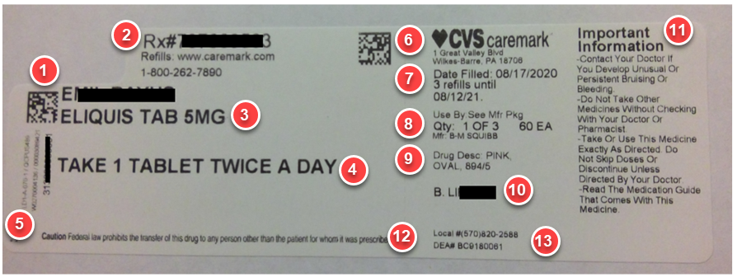

**CHI:**

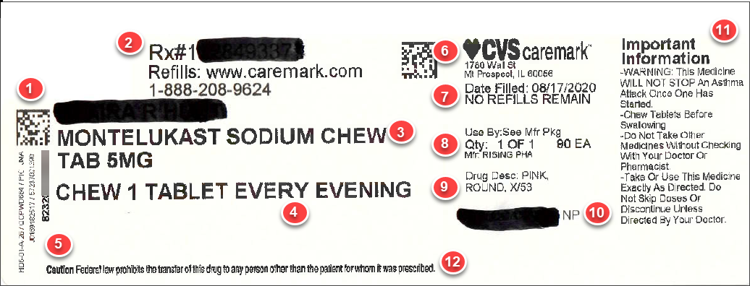

**Parts of the Rx Label:**

|  |  |
| --- | --- |
| **Feature** | **Description** |
| **1** | **Patient Information:** Name of the patient who the medication is for. |
| **2** | **Prescription Number:** The patient’s prescription number. |
| **3** | **Rx Information:** The name and strength of the medication. |
| **4** | **Directions:** This is the way the member is prescribed by the Doctor to take the medication. |
| **5** | **Vertical:** Contains theVial barcode and drug location. IsPrinted along far left-hand side of the label. |
| **6** | **Home Delivery Information:** The address of the member’s Mail Order Delivery (MOD) office. |
| **7** | **Date Filled and Refills Remaining:** This is the date the prescription was filled along with the number of refills remaining and when the prescription expires. |
| **8** | **Manufacturer Name:** This is the name of the manufacturer of the prescription inside the bottle. |
| **9** | **Drug Description:** Description of the medication that was filled. |
| **10** | **Prescriber:** This is the name of the Member’s Doctor who wrote the prescription. |
| **11** | **Use Information:** Important use information for the medication. |
| **12** | **Federal Caution Statement:** Preprinted along bottom of label. |
| **13** | **WBP ONLY:** The DEA Number and local pharmacy phone #. |

**Examples of CVS and Manufacture Bottles/Boxes:** Medication for patients’ orders come in a variety of different shapes and sizes.

Below are some examples:

|  |  |
| --- | --- |
| **Image** | **Description** |
|  | Amber vials used for Tabelts/Capsules ranging in size from 120CC to 300CC. |
|  | Amber vials used to dispense liquid medication. They range in size from 60ML to 500ML. |
| **CHI (also used for small items):** | Amber vials or jewelry boxes used to dispense medicatons in glass containers or that are too small to properly apply the patient label.  **Small glass and containers:** |
|  | Various manufactuer bottles shown. |
|  | Various manufactuer boxes shown. |

Top of the Document

|  |
| --- |
| Examples of Applied Labels |

Orders received from the CVS Caremark Mail Order Pharmacy may contain prescriptions with a variety of prescription labels depending on how the medication is dispensed. The prescription labels may be applied in different way, depending on the product and/or the location it was dispensed.

Below are some examples:

|  |  |
| --- | --- |
| **Image** | **Description** |
|  | Label is applied around the product. |
|  | Label is applied with a flag through Automation. (Label is not adhered to product on both ends.) |
|  | Label applied with a flag manually. (Label adhered to the product on both ends.) |
|  | Label applied with a flag and PEEL HERE tab through Automation. |

Top of the Document

|  |
| --- |
| Applying the Label Manually |

Adhere the prescription label neatly on the package or amber vial. Prevent placing the label in areas where the package will be opened.

**Manual Pick**

* Amber Vials:
  + Wrap label entirely around the bottle ensuring visibility of the medication at both the top and bottom of the vial.
* Manufacturer Products:
  + Verify three S’s and Q
    - **S**ealed
    - **S**afety Cap
    - **S**ize of Bottle allows for labeling. **Note:** The label cannot cover the top of the bottle cap.
    - **Q**uantity
  + Full Medication Name and Strength or NDC must be visible.
  + Attempt to cover Lot Number and Expiration Date.
  + Product Warning Label must be visible.

**Unit of Use**

* Manufacturer Products:
  + Full Medication Name and Strength or NDC must be visible.
    - Leave open UPC/2D.
  + Do not cover the Lot Number and Expiration Date.
  + Product Warning Label must be visible.

Top of the Document

|  |
| --- |
| Flagging Labels |

It is important to create the flag appropriately. Flagging should be avoided whenever possible.

**To Create the Flag**

On the 5.25 inch or 6 inch label - fold along the perforated area after the 2nd QR barcode.

**Note:** Both ends of the label must be completely adhered to the package or amber vial.

For more information, refer to [Manual Pick Overview (070891)](https://thesource.cvshealth.com/nuxeo/thesource/#!/view?docid=368ea74a-a6b4-4c34-8a0d-b210a38803eb).

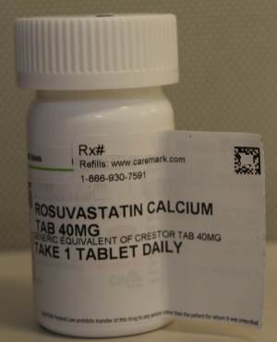 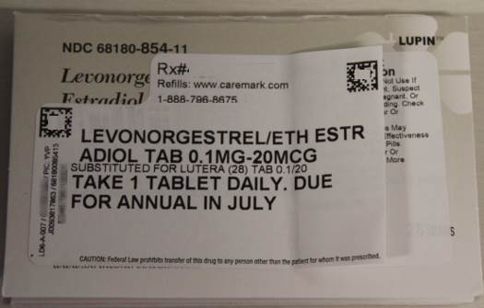 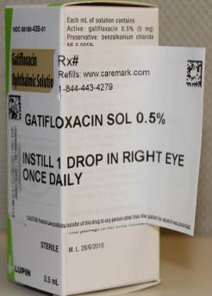 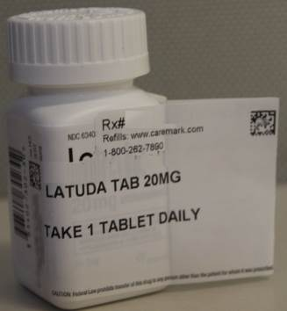

Top of the Document

Not To Be Reproduced Or Disclosed to Others Without Prior Written Approval

**ELECTRONIC DATA = OFFICIAL VERSION / PAPER COPY = INFORMATIONAL ONLY**